UNSTRUCTURED DATABASE LAB 4 | 09.02.2026
Name: Sandip Maity,
Roll No: UG/SOET/165/23/082,
Reg. No: AU/2023/0009995
DATABASE: collegeDB_AIML82,
COLLECTION: studentList_AIML82
Insert all data in table
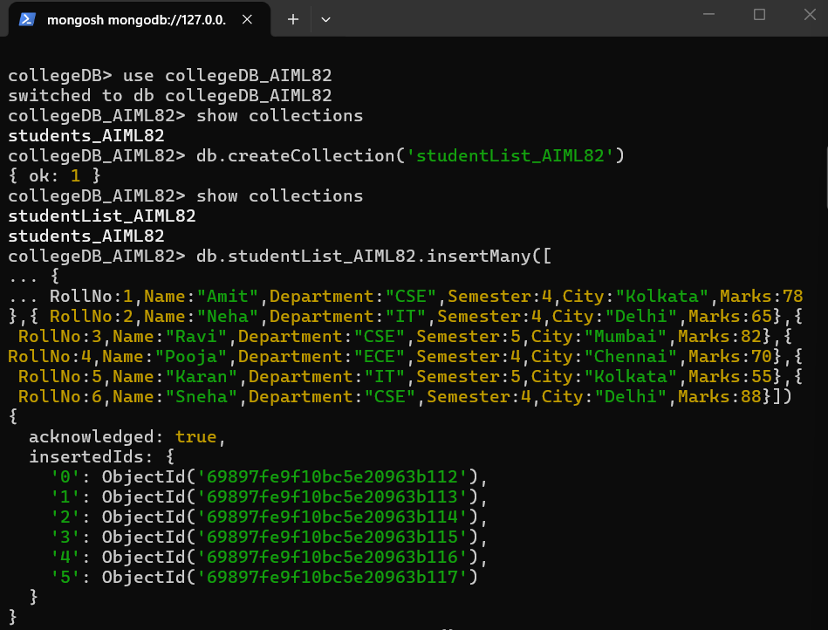
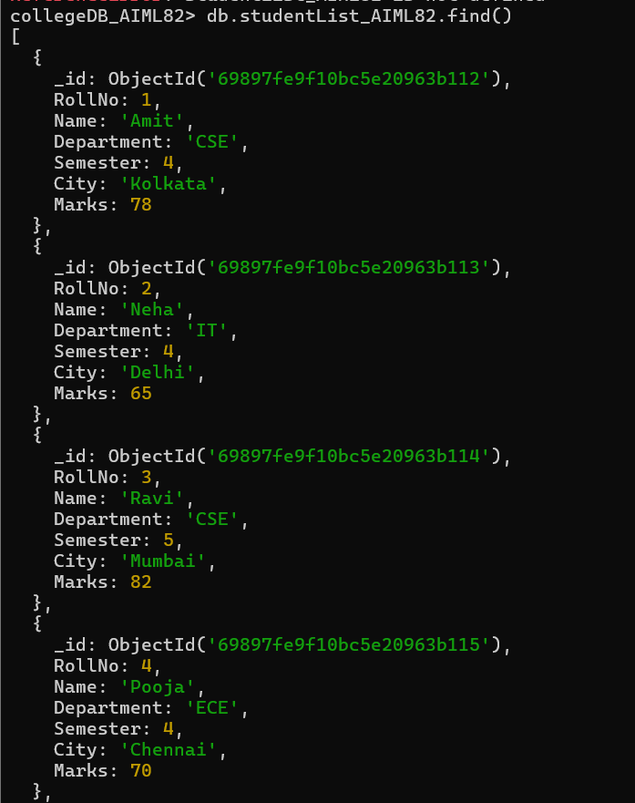
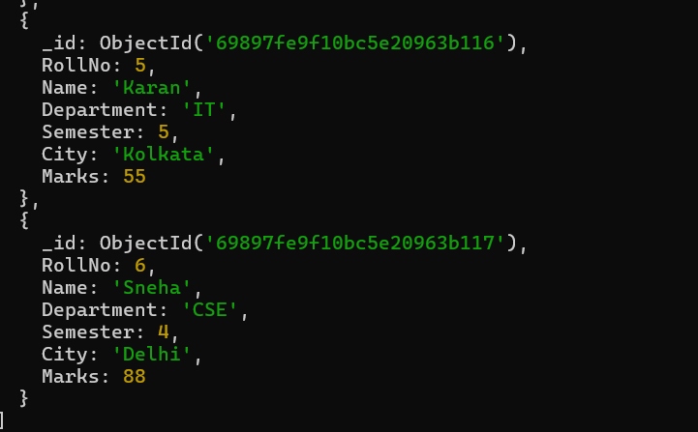

Q1. Display all student records using aggregation
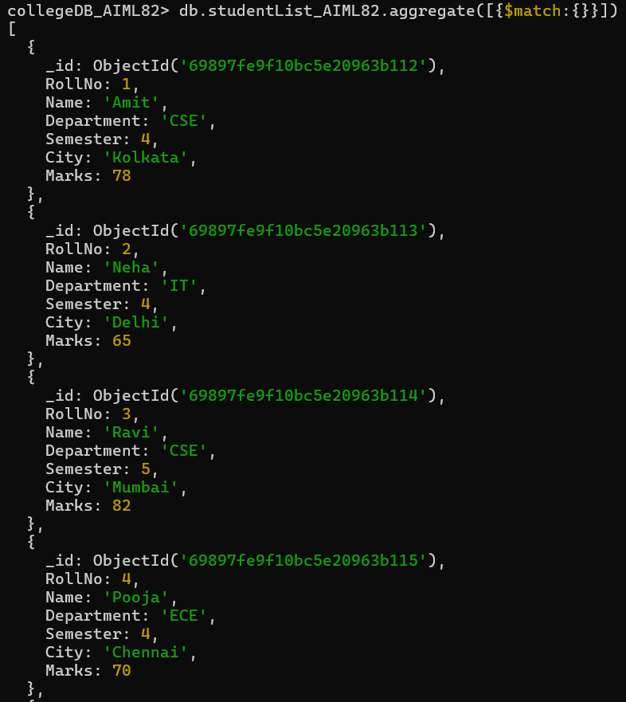
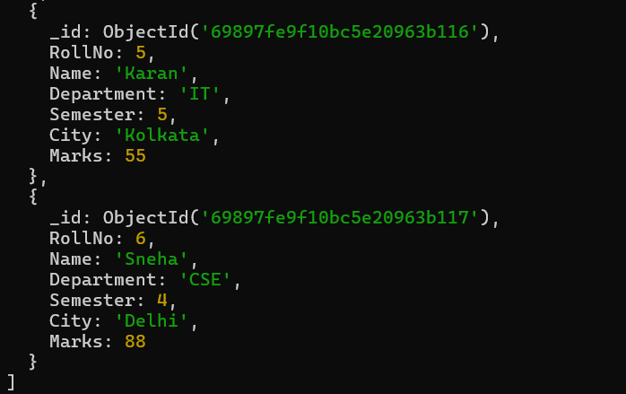

Q2. Display students belonging to CSE department
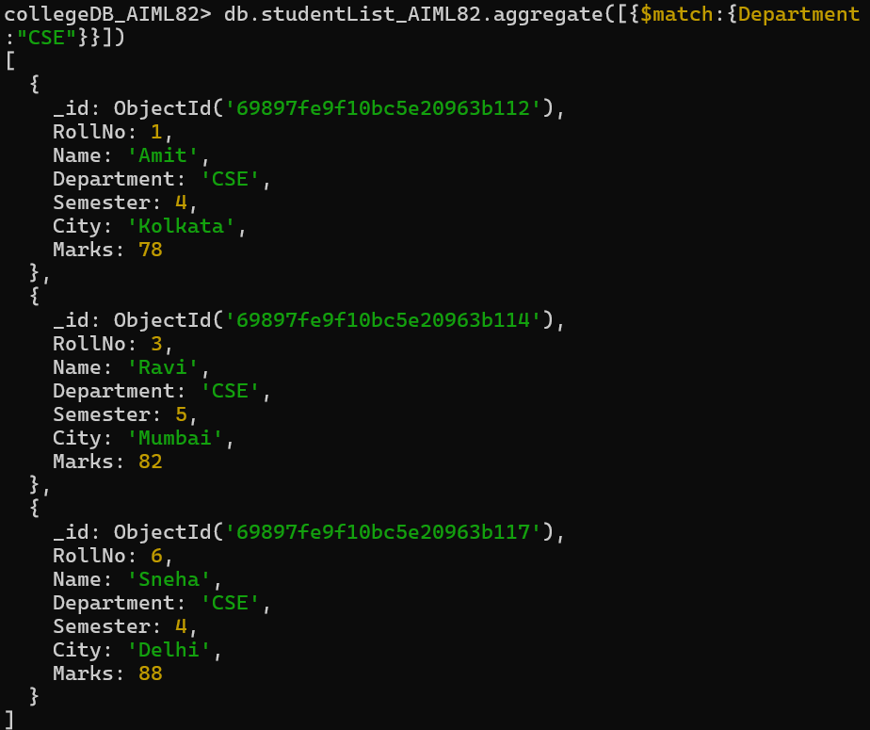

Q3. Display students of semester 4
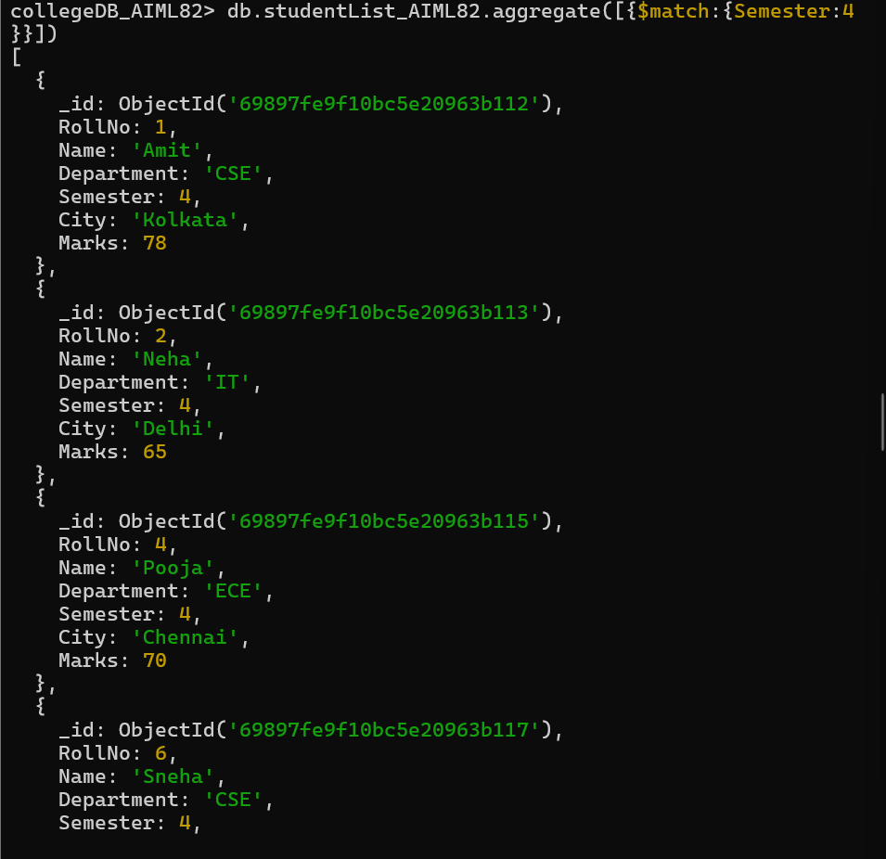
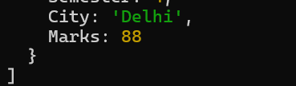

Q4. Display only name and marks of all students
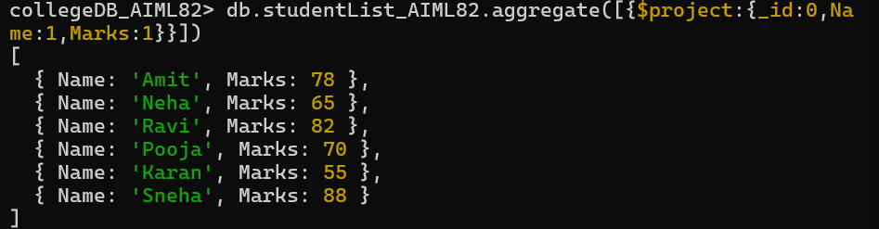
Q5. Find the average marks of all students
Q6. Find total marks scored department-wise
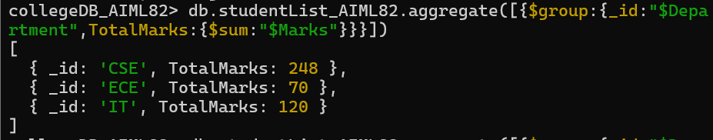
Q7. Find average marks department-wise
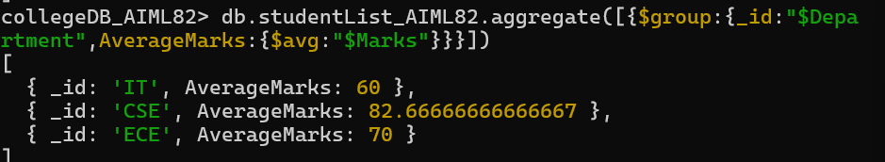
Q8. Find maximum marks scored in each department
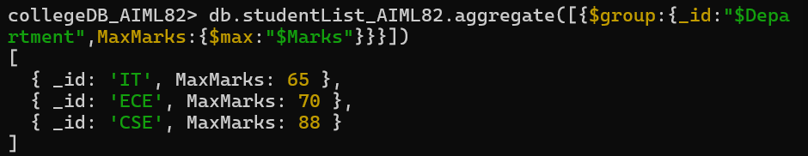
Q9. Count number of students in each department
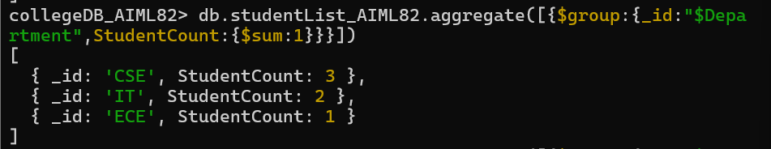
Q10. Display departments having average marks greater than 70
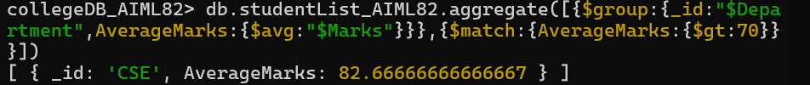
Q11. Sort students by marks in descending order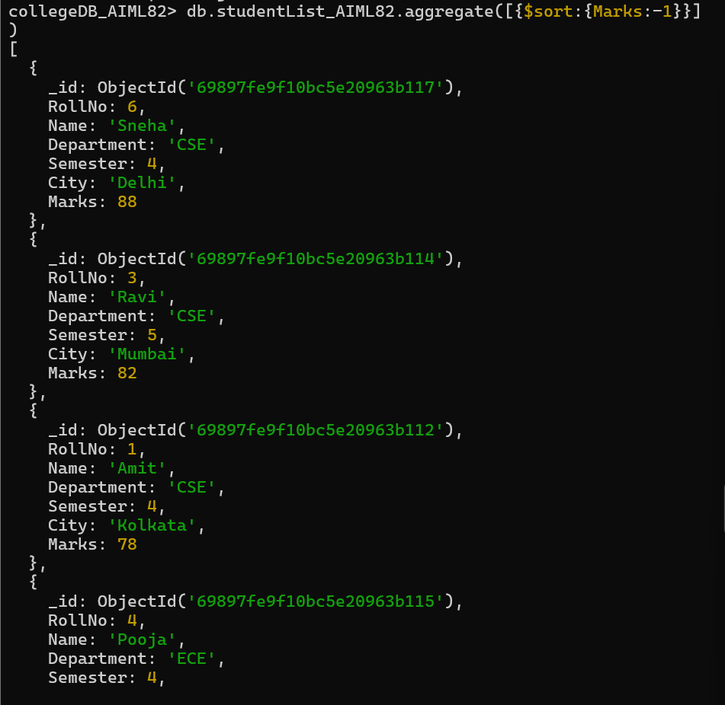
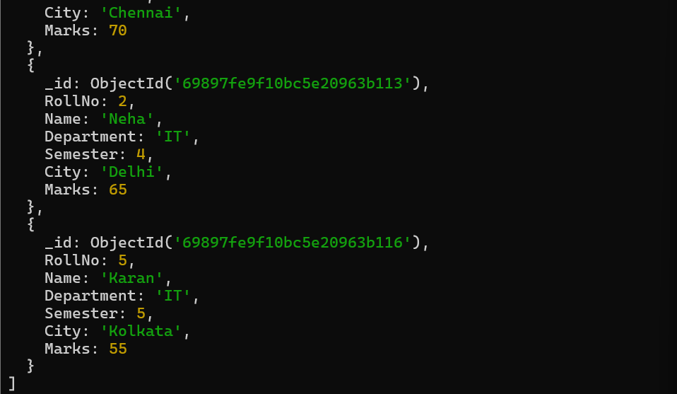

Q12. Display top 3 students based on marks
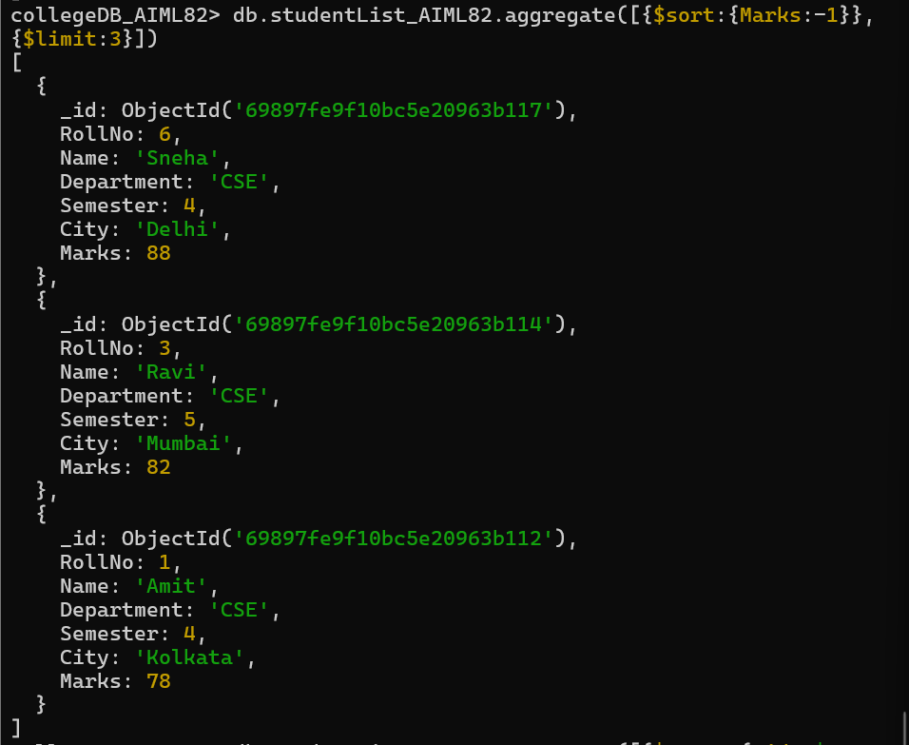
Q13. Display department-wise average marks sorted in descending order
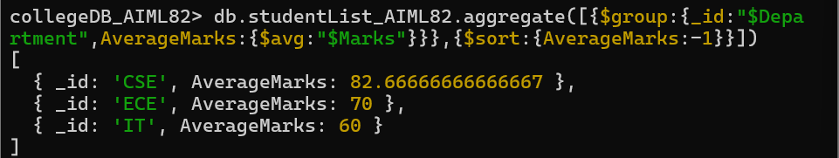

Q14. Display students belonging to Delhi or Kolkata
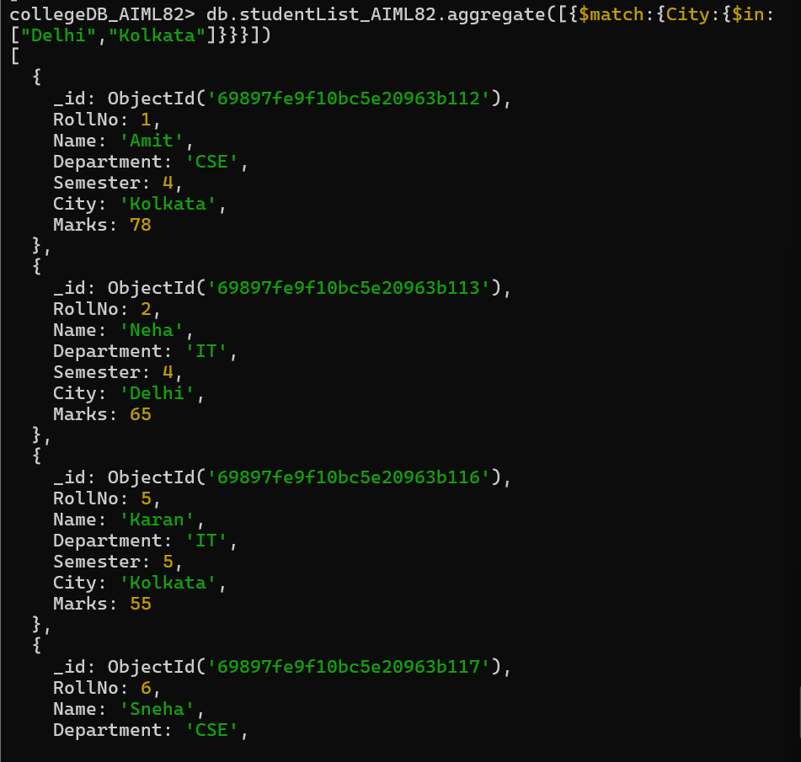
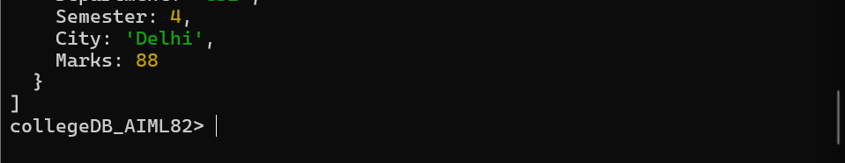
MONGODB COMPASS
